Star Wars and the Hero’s Journey

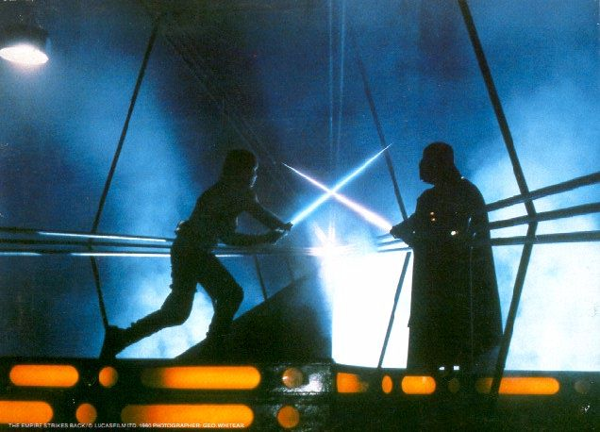

Star Wars and the Hero’s Journey 1
Hero’s Journey Tables 5
Basic Structure 5
Steps in the Hero Journey 7
The Hero’s Journey Crossword 9
Stages of the Hero’s Journey Exercise 11
Theseus and the Minotaur 12
Theseus Vocabulary 14
The Hero Theseus Story Summary 14
The Hero Theseus Story Summary – Detailed version 15
The Hero Myth and Star Wars 16
Star Wars and the Hero Myth Worksheet 17
The Hero Myth Worksheet 19
Self Evaluation 23
Mythology Resources Online 25
Answers 26
Pronunciation Guide 32
Additional Resources for Optional Activities and Discussion 33
List of Star Wars Characters 34
Star Wars Organizations 35
Plot Summaries 36
Star Wars Episode IV: A New Hope 36
Star Wars Episode V: The Empire Strikes Back 38

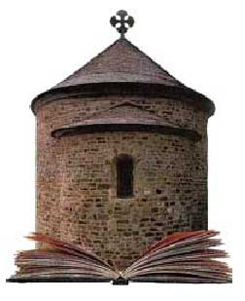

Castlebooks Lesson Plans TM
are published by:

Castlebooks
Suite 102 19 Dallas Rd.
Victoria BC

Canada V8V 5A6

Visit our Website at http://www.castlebooks.com

Call us Toll Free 1-877-889-2573

Copyright © Castlebooks Inc.
All rights reserved. This book, or parts thereof may not be
reproduced in any form without permission. Please visit our website for more information.
Terms of Use Copyright Information

Printed in Canada .

Hero’s Journey Tables

Basic Structure

 | Wizard of Oz | The Lion King | Buddha
Departure | Dorothy is swept away from Kansas in a Tornado | Simba’s father is killed and he leaves to regain his father’s kingdom. | Siddhartha leaves his fathers palace
Journey | Dorothy travels to the Emerald City to see the Wizard | Simba’s life in the wilderness. | Siddhartha searches for a way to free himself. Sits under the Bodhi tree.
Return | Dorothy returns to her home in Kansas | Simba fights and defeats Scar and wins the throne. | Siddhartha returns to the world that he has given up to make disciples.

 | The Wizard of Oz | The Lion King | The Matrix
Ordinary Life | Dorothy lives in Kansas with her Aunt and Uncle |  | Neo has a boring job for a software company
Call to Adventure | Mrs. Gulch takes away Toto and Dorothy runs away. | Simba’s father is killed | Neo has the chance to meet Morpheus
Threshold Crossing | No threshold | No threshold | Neo chooses between the pills
Departure | tornado sweeps Dorothy away to the land of Oz | Simba flees from the Pride Lands | Neo chooses the red pill
Meeting Allies | Dorothy meets the Tin Woodman, Cowardly Lion, and the Scarecrow. | Pumbaa the warthog and Timon the meerkat | Neo meets the crew of the Nebuchadnezzar.
Gift | Ruby slippers from the wicked witch | Simba has Rafiki, perform a future king ceremony.
Mentor | The good witch Gelinda, | Simba’s father Mufasa | Morpheus
Journey | The Yellow Brick Road | Travels through the wilderness with Pumbaa and Timon | Joins the crew of the Nebuchadnezzar
Final Ordeal or Confrontation | Caught by the Wicked Witch | Simba must defeat Scar and the hyenas | Neo fights Agent Smith in the Subway station
Return | Dorothy’s knowledge that "There’s no place like Home" | Simba regains his father’s throne. | Neo defeats/rises above the Matrix

Steps in the Hero Journey

Humble Beginnings
The Hero Journey starts in ordinary life. The hero is an ordinary person living in ordinary circumstances. Readers can relate to the hero because he or she is like them. This also lets the readers know that extraordinary things start in ordinary life. Star Wars begins with Luke living in Tatooine as an ‘ordinary guy.’ The wizard of Oz begins with Dorothy living in Kansas as an ‘ordinary girl’ in ordinary circumstances.

Call to Adventure
The Call to Adventure is an event that pulls the Hero out of everyday life. Something happens which begins the adventure. Often the Hero does not have a choice, but sometimes they do. The call to adventure in The Wizard of Oz is when Miss Gulch takes Toto away. Dorothy is faced with a choice of accepting this, or doing something about it. This is her Call to Adventure.

Threshold Crossing
Usually, but not always in Myth, the Hero must make a decision and after that everything is changed. The threshold is the last chance to turn back. After the hero crosses, nothing will be the same and they cannot go back to their old life.

In the Matrix, Neo meets is given the choice of the red pill or the blue pill. If he takes the red pill, he will learn the truth of the Matrix. If he takes the blue pill, he will wake up in bed and remember nothing.

Departure
In mythology, and in movies that are based on mythology, the hero travels from the everyday world to the mythic world. In the mythic world, fantastic and amazing things can happen. Sometimes the mythic world looks just like the real world of everyday life, but still fantastic things happen.

Dorothy travels to the mythic world of Oz in a house with the tornado.
In the Matrix, Neo, after choosing the red pill, is transported to the terrible and dangerous world of the Matrix.

Meeting Allies
Once in the mythic world, the Hero meets friends or allies, who help him or her in their quest. The allies and the hero face many obstacles together and learn to work together. Also, the allies often live in the mythic world, and can help the hero because of this.

Dorothy meets the Cowardly Lion, the Tin Woodman and the Scarecrow. They have knowledge of the local area that Dorothy does not. They know where the Wizard lives (in the Emerald City) and where the way to the Emerald City.

Gift
The Hero is often (but not always) given a gift that is necessary for them to complete their task. Gelinda gives Dorothy the red slippers.

Meeting the Mentor
Most myths have a teacher or Mentor, who assists the Hero. A common Mentor is an old man or woman. These characters have knowledge which the Hero or Heroine must learn to complete the Quest.

Journey
So far, the Hero has arrived in the mythic world, met their mentor, perhaps received a gift, or some special knowledge, and met their allies. Now they must pursue their quest or goal by taking a journey. Sometimes the journey is simple, like Dorothy in the Wizard of Oz, who follows the Yellow Brick road.

Along the way, the Hero and their allies must confront a series of obstacles or tests. Each test teaches the hero and their friends to work together, and prepares them for the Final Confrontation.

Final Confrontation

As the Hero and the Allies overcome the obstacles, they prepare for the final obstacle or confrontation. This often takes the form of a final battle or a fight with a monster, or perhaps a powerful wizard.

The Return

After facing the final confrontation the hero returns home to everyday life. Their journey and adventures have changed them and perhaps they bring a gift back to their community.

The Hero’s Journey begins, at home, and also ends at home. As Dorothy in the Wizard of Oz says, “There’s no place like home.”

The Hero’s Journey Crossword

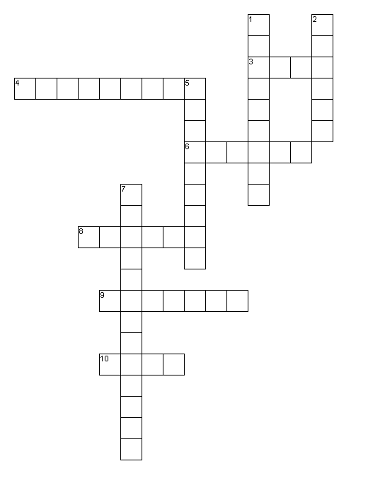
Across
3. Get these at Christmas
4. No turning back after this
6. Friends
8. Often an old man or woman
9. Trip
10. Pulls the Hero out of ordinary life

Down
1. Luke Skywalker lives with his Aunt and Uncle on Tatooine
2. Goes home
5. Leaves the ordinary word
7. The big battle

Stages of the Hero’s Journey Exercise

Below are the stage in the Hero’s Journey – Put them in order. Remember that the Hero’s Journey is a broad pattern, so sometimes the stages may happen in a slightly different order. (HINT: there could be 2 answers)
____ Return
____ Meeting Allies
____ Call to Adventure
____ Departure
____ Ordinary Life
____ Final Ordeal or Confrontation
____ Gift
____ Journey
____ Meeting the Mentor
____ Threshold Crossing

Theseus and the Minotaur
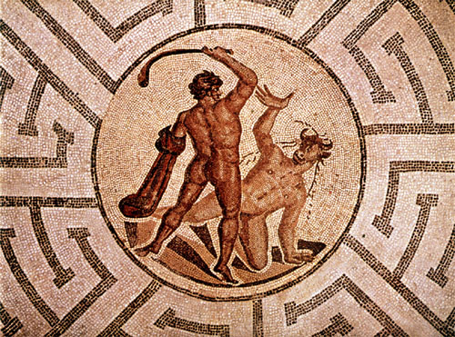

Theseus (The-soos-syoos) is a very famous Greek hero. He was the son of Aegeus, (A-joo-see-us) the King of Athens. Aegeus did not raise his son himself, but sent him far away when Theseus was born because he only want his son know he would be king one day. Like many kings, he also wanted his son to be strong and heroic. To test his son’s strength, Aegeus left a sword hidden under a rock for his son to find when he was old enough and strong enough to move the rock. With the sword, he left a message telling Theseus he was the king’s son.

Theseus grew up in the country, far from Athens, unaware he was the king’s son. Eventually, he became old enough and was able to life the stone and retrieved the sword and message telling him he was the son of King Aegeus. Taking the sword he journeyed to Athens by land, instead of the easier route by sea, and along the way he killed many bandits and thieves and was already a hero when he arrived in Athens.

Theseus was very happy living in Athens, until one year, in the spring he noticed the Athenians became very sad when a ship with a black sail came into the harbor. Theseus asked his why everyone was so sad, but Aegeus wouldn’t tell him. Curious, Theseus went to the harbor and talked to the captain of the ship. The captain told him King Minos (MI-nos) of Crete's eldest son Androgeus had accidentally been killed in Athens. King Minos became very angry and attacked Athens, demanding the Athenians pay a yearly tribute of seven young men and seven young women to be fed to the Minotaur. The Minotaur was a monster that lived in a Labyrinth under the city of Crete. The Labyrinth was an enormous maze so big that once a person enters, he or she will be lost in the maze of tunnels. Half bull, half man, the Minotaur was a terrible monster. Its horns were sharp as knives, and its great hooves could kill even the strongest hero, and its food was human flesh.

When Theseus heard this strange story, he said to his father, "I will go to Crete as one of the victims and I will slay the Minotaur!" "No my son," said Aegeus, "you mustn't go. You are my only son. The only heir to the throne." "I must go father. I must prove that I am a hero,” said Theseus. In the end Aegeus let Theseus go, but made him promise to change the sails of his ship from black to white when he returned. This way Aegeus would know if Theseus was successful slaying the Minotaur.

When Theseus and the other thirteen victims landed at Crete, King Minos welcomed them and asked each of the victims their name. When it was Theseus' turn he said, "I am Theseus, Prince of Athens, son of Poseidon (Poh-SY-duhn)!" Minos replied, "If you are the prince of Athens then Aegeus must be your father. Prove that you are son of Poseidon and fetch my ring." Minos threw his ring into the sea. Praying to Poseidon, Theseus dove into the water. As he swam toward the bottom, he saw the nymph Thetis who gave him the ring and an old crown. Theseus came to the surface holding the ring and the crown. Minos laughed and agreed he must be the son of Poseidon.

That night Minos' daughter Ariadne (Air-ee-ad-nee) visited Theseus. She said, "I have decided to help you kill the Minotaur if you will take me back to Athens and make me your queen." Theseus agreed and promised to take her back to Athens if she helped him. She gave Theseus a ball of thread and told him to tie one end at the entrance of the Labyrinth and unwind the ball of thread as he walked in. This way, when it was time to return, he could simply follow the thread back to the entrance again.

The next day Theseus and the thirteen victims were forced into the labyrinth. Theseus tied the string onto a rock and told everyone to follow him towards the center of the Labyrinth. When they found the Minotaur, it was sleeping. Theseus ripped of one of its horns off and started poking the Minotaur. The Minotaur became enraged. Quickly escaping the Minotaur, Theseus ran back and threw the horn like a spear, hitting the Minotaur in the neck.

The Minotaur charged, but fell over dead before it reached Theseus. They followed the thread back to the entrance of the Labyrinth. Theseus, Ariadne, and the other victims got back on their ship and sailed for Athens. One night the god Dionysus came to Theseus and said, "You mustn't marry Princess Ariadne for I have chosen her as my own bride. Leave her on the island of Naxos." Theseus did as the god told him. He was so sad, he forgot to change the sails from black to white. King Aegeus in Athens had been anxiously waiting for his son to return and when he saw the ship returning with black sails, and thought Theseus had been eaten by the Minotaur. He was so overcome with grief, he jumped off a cliff. The sea he fell into is called the Aegean, after King Aegeus.

Theseus Vocabulary

Tribute – taxes. Money paid to the government in ancient Rome and Greece.
Labyrinth – A maze.
Minotaur – A Monster in Greek Mythology with a human body and a bull's head.

Hooves – Feet of cows, horses, deer or pigs.
Flesh – Skin and muscle
Slay – to kill
Heir -- A person who inherits.

The Hero Theseus Story Summary

Departure | Theseus left Athens with the 13 victims to slay the Minotaur.
Journey | Theseus traveled to Crete by boat.
Return | Theseus returned to Athens with Ariadne

The Hero Theseus Story Summary – Detailed version

Ordinary  Beginnings | Theseus does not know he is the King’s son
Call to Adventure | Theseus sees the injustice of the 14 victims
Crossing the Threshold | Theseus’ father tells him not to go to Crete. He insists and gets into the boat with the others. Once he gets in the boat, he cannot turn back.
Departure | Theseus leaves Athens the boat with the 13 others victims.
Journey | Theseus travels to Crete and then enters the Labyrinth.
Meeting Allies | Theseus meets Ariadne.
Gift | Ariadne gives him the ball of thread.
Final Confrontation | Theseus fights the Minotaur.
Return | Theseus and Ariadne return home to Athens.

The Hero Myth and Star Wars

Class discussion

Departure | Luke’s home on Tatooine is destroyed and his Aunt and Uncle killed. He leaves with Obi Wan Kenobi to deliver the message R2D2 carries to the Rebels.
Journey | Luke joins the rebels and has many adventures.
Return | The Empire is defeated and the Rebels have a party to Celebrate.

Star Wars and the Hero Myth Worksheet

Ordinary
Beginnings

Call to Adventure
Crossing the Threshold

Departure
Journey

Meeting Allies

Gift
Final Confrontation

Return

The Hero Journey Exercises

Who is your hero and why?
____________________________________________________________________
____________________________________________________________________
____________________________________________________________________

What do you value as a person?
____________________________________________________________________
____________________________________________________________________
____________________________________________________________________

What kind of values do you think should be passed on to children in mythology?

____________________________________________________________________
____________________________________________________________________
____________________________________________________________________

Based on your answers to these questions, use the blank worksheets below to create the outline for a hero’s journey.

Departure
Journey

Return

The Hero Myth Worksheet

Ordinary
Beginnings

Call to Adventure
Crossing the Threshold

Departure
Journey

Meeting Allies

Gift
Final Confrontation

Return

Self Evaluation
Read the questions below and rate your understanding from 1 to 10.

I know who Theseus is and what he did.

Do Not Understand |-----|-----|-----|-----|-----|-----|-----|-----|-----| Understand Very Well
1 2 3 4 5 6 7 8 9 10

I understand and can recognize the Hero’s Journey pattern.

Do Not Understand |-----|-----|-----|-----|-----|-----|-----|-----|-----| Understand Very Well
1 2 3 4 5 6 7 8 9 10

I have learned new vocabulary and can use it.

Do Not Understand |-----|-----|-----|-----|-----|-----|-----|-----|-----| Understand Very Well
1 2 3 4 5 6 7 8 9 10

I can think of at least one movie, book or TV show that follows the Heroes Journey.

Do Not Understand |-----|-----|-----|-----|-----|-----|-----|-----|-----| Understand Very Well
1 2 3 4 5 6 7 8 9 10

I know what a Minotaur is.

Do Not Understand |-----|-----|-----|-----|-----|-----|-----|-----|-----| Understand Very Well
1 2 3 4 5 6 7 8 9 10

Mythology Resources Online

What are myths? How did they begin? Use the following Web sites to answer these questions:

Origins of Greek Mythology http://messagenet.com/myths/neomyth.html

Classical Greek Mythology http://alexandria.simplenet.com/myth/index.html

Greek Gods (Immortals) http://www.messagenet.com/myths/immortals.html

Greek Gods http://www.mythweb.com/gods/

Family Tree of Greek Gods

http://www.desy.de/gna/interpedia/greek_myth/godsFT.html

Answers

Heroes Journey Crossword Puzzle

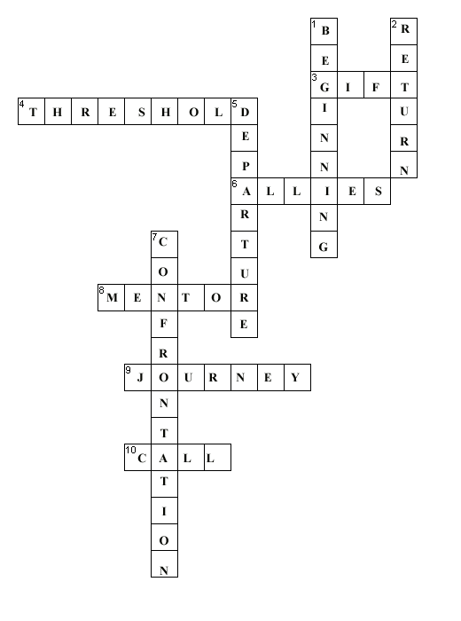

Stages of the Hero’s Journey Exercise

Below are the stage in the Hero’s Journey – Put them in order. Remember that the Hero’s Journey is a broad pattern, so sometimes the stages may happen in a slightly different order. (HINT: there could be 2 answers)
10 Return (ALWAYS be the last)

7 Meeting Allies
2 Call to Adventure (ALWAYS be number 2)
5 Departure
1 Ordinary Life (ALWAYS be first)
9 Ordeal or Confrontation (ALMOST always be second to last)
8 Gift
6 Journey
4 Meeting the Mentor
3 Threshold Crossing

The Hero can meet the allies or mentor (or both) before or after the threshold, or departure.

The Hero may receive the gift before or after Departure and Crossing the Threshold.

Ordinary  Beginnings | Luke lives with his Aunt and Uncle on Tatooine, unaware that he is the son of a famous Jedi Knight
Call to Adventure | When Luke returns from visiting Obi Wan Kenobi, his house has been destroyed.
Crossing the Threshold | Luke goes with Obi Wan, R2D2, and C3PI0 to the Mos Eisley Space Bar. This is his last chance to turn back.
Departure | Luke and his allies leave Tatooine with Han Solo
Journey | Luke joins the Rebels and together they have many adventures.
Meeting Allies | Luke meets many allies. He meets some before Departure, such as Obi Wan and Han Solo, and others such as the Rebels and Princess Leiai.
Gift | Luke receives his fathers Light Sabre from Obi Wan.
Final Confrontation | Luke duels with Darth Vader.
Return | After the Empire is defeated, the Rebels celebrate. Luke does not return ‘home’ in this case but finds a new home and new friends.

Pronunciation Guide

Ariadne Air-ee-ad-nee
Athene Uh-THEE-nee
Augeas Aw-jee-uhs

Augean Aw-jee-un

Danae Dan-ay-ee
Demeter Duh-MEE-tur

Diomedes Dy-oh-meed-eez

Dionysos Di-OH-nee-us
Erymanthian Eriman- theen
Geryon Jer-een
Graeae Gre-i
Hades HAY-deez
Hephaistos Hee-FEHS-tus

Herakles also -- Herakles and Hercules
Hermes HUR-meez

Hesperides Hes-pair-i-deez
Hestia HE-est-tuh

Hippolyte Hi-pahl-i-tee
Labyrinth LAB-erinth

Metis Mee-tis
Minos MI-nos

Odysseus Oh-dis-ee-uhs
Styx Stiks

Theseus Thee-see-uhs

Thetis Thee-tis
Tiryns TI-rinz

Additional Resources for Optional Activities and Discussion

List of Characters

Anakin Skywalker: Anakin is revealed as the real name of Darth Vader
Boba Fett: is one of the most popular characters in the Star Wars universe, despite having relatively little screen time. Boba Fett was a bounty hunter hired by Jabba the Hutt to track down and capture Han Solo.
C-3PO: is a protocol android specifically designed to interact with organics, (people and aliens) C-3PO is one of the longest lived characters in the Star Wars pantheon, appearing in all three films of the original trilogy
Chewbacca: is an 8-foot tall Wookiee and co-pilot of Han Solo's ship, the Millennium Falcon. While Chewie is perfectly able to understand the galactic-standard language Basic, he is unable to speak due to his species' vocal structure.
Darth Maul: Darth Maul was a Dark Lord of the Sith, an apprentice to Darth Sidious. Trained in the ways of the Dark Side of the Force from a young age, Maul had no emotion aside from bloodlust and rage. His master constructed him as a weapon of pure hatred.
Darth Sidious: A Sith lord, Darth Sidious was the prime practitioner of "The Dark Side of the Force".
Darth Vader: is the brutal second-in-command of Palpatine, the Emperor of the Galactic Empire. Formerly Anakin Skywalker.
Han Solo: Solo, a human from Corellia, is a smuggler who flies the Millennium Falcon with the assistance of his Wookiee co-pilot Chewbacca. Solo was once a promising young officer in the Imperial Navy but lost his commission when he first met Chewbacca, then a slave, and helped him escape
Jabba the Hutt: a large slug-like race with thick, leathery skin, human-like arms, large dead-black eyes, and wide mouths. An adult Hutt may weigh in excess of several tons.
Jango Fett: Jango appeared in the movie Attack of the Clones. Jango was to be a template for an army of clones. Was also Boba Fetts Father
Jar Jar Binks: is a fictional character in the Star Wars movies: The Phantom Menace and Attack of the Clones. His primary role was to be comic relief--based on his gangly way of walking, and his Jamaican style of talking.
Lando Calrissian: is a former smuggler and friend of Han Solo who owns and runs a floating city and Tibanna Gas mine on the planet Bespin. After betraying Solo when threatened by Darth Vader in The Empire Strikes Back, Calrissian joins the Rebel Alliance, and in Return of the Jedi rescues Solo, and leads the Rebel starfighter fleet (in the Millennium Falcon previously owned by him) into the Death Star to destroy the massive space station.
Luke Skywalker: He is the son of Padme Amidala and Anakin Skywalker, and brother of Princess Leia Organa. He is a Jedi Knight, who plays a major role in the series of films.
Obi-Wan Kenobi: He taught both Anakin and Luke Skywalker in the ways of the Force.
Padme Amidala: is the mother of Princess Leia and Luke Skywalker, and democratically-elected Queen of Naboo, and later represents the planet as a Senator in the Galactic Senate. Amidala plays an important role in the last years of the Old Republic.
Palpatine: is a scheming politician who eventually emerges as the series' main villain. At the beginning of Star Wars Episode I: The Phantom Menace, Palpatine represents the planet Naboo in the Senate of the Galactic Republic and by the end of the movie has manipulated events to become Supreme Chancellor of the Republic.
Princess Leia: is the daughter of Padme Amidala and Anakin Skywalker, and twin sister of Luke Skywalker (though this is not revealed unambiguously until Return of the Jedi).
R2-D2: is an astromech droid and friend of C-3PO
Yoda: is arguably the most powerful Jedi Master in Star Wars and one of the senior members of the Jedi Council. In his career as a Jedi Master, Yoda has trained several Jedi worth mentioning, including Count Dooku, Mace Windu, Obi-Wan Kenobi, and Luke Skywalker.

Star Wars Organizations

Galactic Republic: was the name of the interplanetary government used in the fictional Star Wars universe prior to the establishment of the Galactic Empire.

Galactic Empire: the Galactic Empire was the regime established by Palpatine to replace the Galactic Republic.

Confederacy of Independent Systems: is a fictional organization that existed in the Star Wars universe in the latter years of the Republic. The organization was made up of organizations and Star Systems that wanted to leave the Republic, numbering "thousands" and with at least "ten thousand ready to join". Several corporations such as the Trade Federation, Commerce Guild, and Intergalactic Banking Clan, among others, also joined. The organization's main goal was to split from the Republic and form their own republic, saying the Republic had become too corrupt. The members of this organization are called Separatists.

Kuat Drive Yards: is the largest military shipbuilding corporation in the Star Wars universe and owns several subsidiary corporations including Kuat Systems Engineering and Rothana Heavy Engineering (the latter of which provided armament and ships for Supreme Chancellor Palpatine's clone army during Attack of the Clones). KDY is one of the few major corporations which sided with the Galactic government during the Clone Wars, against the Commonwealth of Independent Systems.

Jedi: is a fictional religion from the Star Wars series.

Rebel Alliance: was a group formed in direct military opposition to the Galactic Empire.

New Republic: is a fictional government from the Star Wars movie series. When the Rebel Alliance re-established the Galactic Republic it became known as the New Republic, as the original Galactic Republic had become known as the Old Republic by this time.

New Republic Senate: The Senate served as the governing body of the Galactic Republic, while the Jedi Order served as its defenders. The Republic began as a mutual protection and economic alliance among a number of planets in the galactic core.

Sith: are a group of warrior priests who follow the "dark" side of The Force. Members of the Sith adopt names that are always preceded by "Darth". The word sith is Celtic for fairy.

Trade Federation: is a fictional organization that exists in the Star Wars universe at the time of the Galactic Republic.

Plot Summaries

Star Wars Episode IV: A New Hope

Plot summary
Two droids, C-3PO and the feisty R2-D2, come into the possession of Luke Skywalker, a young, frustrated resident of a remote settlement on the planet Tatooine. The planet is on the largely ignored frontier regions of the tyrannical Galactic Empire, led by Emperor Palpatine. Luke discovers that the droid contains a video message from a mysterious, attractive Princess Leia, and plans for a huge weapon, the Death Star. A sequence of events leads the droid, and Luke, meeting Obi-Wan Kenobi, who asks for Luke's assistance to take the droids and the plans to the rebel base on Alderaan as requested by Leia. Luke is reluctant at first, but after returning home to find his family murdered and his house destroyed by Imperial Stormtroopers, decides to join Obi-Wan.
Meanwhile, Darth Vader, on the Death Star where Leia is imprisoned, attempts to use the ways of The Force to extract the location of the Rebel Base from her. She has managed to resist the interrogation thus far. The commanding officer of the station, Grand Moff Tarkin, decides on a different approach and threatens Alderaan with destruction if she will not reveal the location. Leia gives in and reveals the base's location. The admiral blows up Alderaan anyway, as a public display of the Death Star's power.

The scene then shifts back to Obi-Wan, Luke, and the droids. As they arrive at a seedy spaceport bar, Obi-Wan mysteriously convinces Imperial Stormtroopers that the droids accompanying him "are not the droids you're looking for". They then meet up with boastful smuggler Han Solo. He agrees to take them to Alderaan on the promise of a large financial reward. However, the Storm Troopers return in numbers and they just make it to Solo's ship, the Millennium Falcon, in time to escape.

On the way to Alderaan, Kenobi begins instructing Luke on the ways of the Force. Solo is sceptical, but a blindfolded Luke is able to sense the location of an attacker whilst practising with a light saber.

Arriving at Alderaan, or, at least, where Alderaan should be, the crew of the Falcon are surprised to discover there's nothing there except a hail of debris. They are even more surprised to be hauled by tractor beams aboard a moon-sized space station — the Death Star. Hiding in secret smuggling compartments of their ship, they manage to evade capture, and decide to attempt to disable the tractor beams holding them there. In the process, they discover Leia is being held in a nearby cell. Kenobi volunteers to disable the tractor beam, whilst Luke (and Han, after some persuasion) go to rescue Leia.

After switching off the tractor beams, Kenobi encounters Vader, who attacks him. It is clear that they have met before, but not how. Kenobi tells Vader in the clash that "If you strike me down, I will become more powerful than you can possibly imagine". When Kenobi sees that he has distracted the guard around the Falcon which allows his friends to board it and his own escape is cut off; he allows himself to be cut down by Vader, only to mysteriously disappear.

Meanwhile, after various adventures, Leia, Luke, Han and Chewbacca make their way back to the Falcon, and escape, fighting off Imperial Starfighters, finally reaching the Rebel hideout where they pass the plans on to the Rebel leadership. Unknown to them, but suspected by Leia, the Empire allowed them to escape in order to track the ship to the Rebel Base, which turns out to be the forest moon of Yavin.

The film then abruptly shifts to a briefing to a group of pilots about the Death Star, and the Rebel plans to attack it by flying along a canyon-size groove in the Death Star's surface, firing a torpedo down a narrow ventilation shaft which will travel down to the reactor and destroy it. Luke is amongst the X-Wing pilots of Red Group. Luke pleads with Han Solo to join them, but Han decides to leave with his reward.

The rest of the film shows the attack by the Rebels on the Death Star. Luke and a few others make it down to the canyon, with Darth Vader in an unusual-looking TIE Fighter in pursuit. Instead of using the electronic aiming gear of the others, Luke is advised by Kenobi’s voice to "use the Force" to aim his torpedoes. With the aid of Solo coming back and attacking Vader's fighter, Luke successfully launches a torpedo down the shaft, destroying the Death Star and striking a huge blow for the Rebellion against the Empire.

Star Wars Episode V: The Empire Strikes Back

Plot Summary
After the destruction of the first Death Star, the Galactic Empire under the control of the dictator Emperor Palpatine and his enforcer Darth Vader. They both seek revenge upon the Rebel Alliance by staging a surprise attack, forcing the Rebels to evacuate their base on the ice planet Hoth.

Luke Skywalker, after ensuring that the Rebel fleet had escaped to safety, heads to the Dagobah System with his droid companion R2-D2 in order to continue his training as a Jedi-Knight under the direction of Yoda - a powerful Jedi-Master. Princess Leia, Han Solo, Chewbacca and the droid C-3PO make their way to Cloud City, a gas-mining colony run by an "old friend" of Solo's named Lando Calrissian. Initially betrayed by Calrissian, they become the captives of Darth Vader who proceeds to torture them.

Luke, as Vader hoped, senses through The Force that his friends were in distress and, disobeying Yoda's warning, goes to Cloud City to rescue them. There, he meets with Vader and the two fight in a lightsaber duel, where Luke's undeveloped Jedi skills are no match for Vader. During the course of this fight, Vader reveals to Luke that he is his father in perhaps one of the most memorable scenes in movie history.

Vader hands over Han Solo to bounty hunter Boba Fett who freezes him in carbonite. Fett transports him to Tatooine to receive a bounty from gangster Jabba the Hutt (whom Han owed a debt). Leia, Chewbacca, C-3PO and R2-D2 are able to escape from Cloud City with the aid of the redeemed Calrissian, but Leia mysteriously senses Luke is in trouble.

Despite having his hand amputated in combat, Luke manages to escape from Vader and hangs on an antenna complex under the city until Leia and Lando are able to return and rescue him. The group was almost caught when they learned the hard way with Vader in pursuit that the Millennium Falcon's hyperdrive system was deactivated to prevent their escape. However, R2-D2 managed to fix the system just in time for the ship to get away before they were captured.

The film ends on a medical ship where Luke is outfitted with an artificial hand. Luke, Leia and the droids say goodbye to Lando and Chewie and begin their quest to rescue Han.

